**Table Creation Script**

CREATE TABLE staging.weather_data

(

forecastsitecode integer,

observationtime integer,

observationdate timestamp,

winddirection integer,

windspeed integer,

windgust decimal(8,2),

visibility decimal(8,2),

screentemperature decimal(8,2),

pressure decimal(8,2),

significantweathercode integer,

sitename varchar(50),

latitude decimal(8,2),

longitude decimal(8,2),

region varchar(50),

country varchar(50)

);

**Query Outputs Screenshots**

**Max Temperature in the given Weather Data Set**

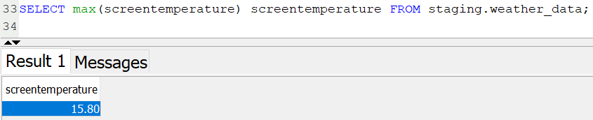

**Which date was the hottest day?**

**What was the temperature on that day?**

**In which region was the hottest day?**

